Capstone Seminar Spring 2021

Professor Heather Dewey-Hagborg

Capstone Mentor Michael Shiloh

Aleksandra Medina

**Draft: The Mischievous Algorithm**

During my time studying Interactive Media, I have gravitated towards a specific aesthetic and ideas that push the notion of interaction between human and machine to be interesting and experimental grounds. It has always been my preference to experiment with ideas rather than experiment with the newest technologies available. Without knowing the name and history behind it, I admired the Bauhaus movement for its emphasis on functionality and reduction to core attributes. In the Manifesto of the Bauhaus movement (1919), Walter Gropius writes “architects, painters and sculptors must learn a new way of seeing and understanding the composite character of the building, both as a totality and in terms of its parts.” Interactive Media is a discipline that teaches its practitioners to break down their tools in order to fully understand them and then build their art from ground up. As Christiane Paul interestingly points out in her book *Digital Art:* “code has also been referred to as the medium, the ‘paint and canvas’, of the digital artist but it transcends this metaphor in that it even allows artists to write their own tools - to stay with the metaphor, the medium in this case enables the artist to create the paintbrush and palette”. This unique and empowering approach to creation is what encapsulates the meaning of Interactive Media represented in this project.

My work is a networked program that gives instructions to two or more users (however, two seems to be the ideal number, otherwise the process becomes frustrating), working real-time to create a collaborative drawing. However, there is a twist. A third ‘hidden’ player is the Mischievous Algorithm, built by me, which introduces uncertainty by bringing in new elements or changes into the users’ work. Adapting to a remote presentation of the project, the users’ side can be varied depending on the hardware that is available to them, presumably, most users will access this project through a laptop. Ideally, the project consists of two iPads and two Apple pencils to ease the drawing process and give users more control. On these iPads, accessed through a link hosted on a service called Ngrok, users are presented with an interface similar to Windows Paint, but built using p5.js. It has three parts: a set of instructions, a canvas for drawing and a minimal tool set derived from common drawing apps, which includes a color picker, the ability to change brush size and an eraser (Image 1 and Image 2). Initially, there was an idea to also include a simple messaging functionality – just enough to create a feeling of collaboration but not enough to erase the uncertainty. However, user testing revealed that the messaging functionality became too distracting and, since its core purpose was lifting some of the uncertainty, the messaging functionality was easily replaced by giving clear instructions before users access the canvas. Thus, the decision was made to clearly explain to users the presence of the third mischievous player in the initial instructions, otherwise users kept thinking there was a glitch and would continuously refresh the page. It is important to keep the complete interface as simple and familiar as possible to avoid frustrations and be able to focus on the relationship between the users and the algorithm. While users are interacting with each other through the canvas, on the backend, there is the Mischievous Algorithm that changes the users’ work in ways that only a computer could do (Image 3).

*Image 1 – Mockup of the interface: Instructions Image 2 – Mockup of the interface: Canvas*

*Image 3 – Sketch of mechanism*

The work has been inspired by a personal favorite quote attributed to Melvin Krunzberg who said that “technology is neither good nor bad; nor is it neutral”. However, headlines by governments and news media scaring people about algorithms taking their liberties and livelihood away (often rightfully so), have caused a large proportion of the society to see algorithms as a dangerous entity that will ultimately hurt the society. My hypothesis is that people fear what they don’t understand. This is the building block of my project: it is an algorithm that explicitly shows what it is doing, moreover, it is meant to bring joy, excitement and spark creativity. It is important to me that the algorithm is a friendly and playful agent that appears and disappears at random, bringing excitement, unpredictability and a little bit of fun chaos. It enables users to create something they would not have been able to imagine by themselves. The Mischievous Algorithm produces results that are clearly non-human, but are still seen as aesthetically pleasing and, hopefully, valuable.

The idea for this work stands on the shoulders of many great artists and academics who have explored these concepts through creative and thought-provoking pieces, allowing me to build on with my personal perspective. In the scope of my work, I want to emphasize the works of Joseph Nechvatal, Chris Finley and Sol LeWitt, who I will introduce throughout this paper. I will also touch upon the writings of Frieder Nake, Edward Shanken, Christiane Paul and Jean Baudrillard.

The aspects of Dadaism have proved influential when considering the form of the project; especially its approach to “using formal instructions to create an artifice that resulted from an interplay of randomness and control” (Paul). My work reverses the expected role of human vs. machine behavior through the interface where the user follows direct instructions to create a piece of digital art, while the interfering code creatively and unexpectedly modifies it (Attachment 1). Frieder Nake (German, 1938- ), best known internationally for his contributions to the earliest manifestations of computer art, articulates this point when he coined the computer as a “Universal Picture Generator”. The computer has the capability of producing every possible combination of given variables so that any input by the user can be randomized beyond imagination and expectation. In an essay named “Computers and Creativity”, Nake explains the mathematical algorithms that are hidden behind his complex polygons created in the 1960s. Given the computing power we are accustomed to, these renderings might seem far from extraordinary, however Nake’s pioneering work is dealing with the earliest days of computer generated art. Even today, when seeing his work, a viewer will immediately sense the presence of an algorithm based on mathematical logic caused by the complexity of the visual outcome.

A similar concept has been imagined by Vera Molnar (French, 1924- ). She called it the ‘machine imaginaire’ envisioning the computer to be able to “produce combinations of forms never seen before, either in nature or museums, to create unimaginable images” (Shanken) furthering my concept of an unpredictable computer and predictable human.

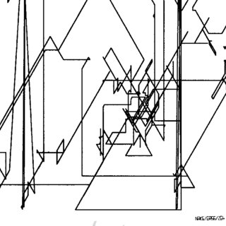

*Image 4 – Frieder Nake “Random Polygon”, 1965*

When discussing structure, Joseph Nechvatal’s (American, 1951- ) computer-robot assisted paintings are my main inspiration. He develops a virus-like computer program that “performs a degradation and transformation of the image” (Paul). The artist himself is not involved in the physical creation of the painting – the process starts with the ‘infection’ by the virus that manipulates the image and is then transferred to a remote computer-driven robotic painting machine that executes the painting in its physical form (Image 5). While the computer is working as the symbolic villain infecting an image as a virus, the results are aesthetically pleasing. At the same time, these paintings remind us of something alien, something not created by the hands of a human. The idea of the computer acting as a ‘virus’ is an idea that I have chosen to build upon and expand in my own work. However, I have chosen to create an algorithm that distances itself from the preconceived notions of a ‘virus’. It is characterized more as a welcomed playful third agent.

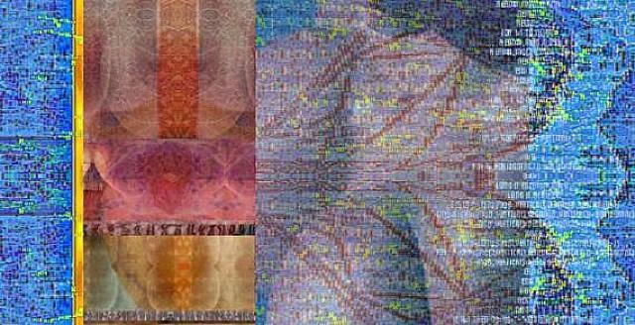

*Image 5 – Joseph Nechvatal “vOluptuary drOid Décolletage”, 2007*

It is important to me that in my work I explore the ‘mysterious back end’ of the computer – a theme that permeates the works of many media artists. While I (the creator) know exactly what the code is doing, my work reminds the user that the machine is a construction. It is also important, through the use of more detailed instructions presented before users access the canvas (Attachment 2), to show that an algorithm isn’t a mysterious entity that exists somewhere out there in a metaphorical cloud. It is an intentionally constructed program that follows the orders of the creator. With technology’s ubiquity and what can only be called today’s technophilia, we tend to forget that there is code ‘living inside’ a computer. The machine does not work for the user; it follows its instructions given by the programmer. And interesting things happen, when the instructions tell the computer to do things at random.

Chris Finley’s (American, 1971- ) work is interesting for its frequent use of digital templates that are created by the artist himself. The artist’s works mirror widespread imaging software by limiting the variations of each piece to a set of options determining color, shape, and form, which is something that I have incorporated in my early prototypes as well. He further manipulates his copies or simulacra by rotation. The result (Image 6) is what appears to be a ‘glitchy’ copy of an original (which, of course, doesn’t exist!). Finley imposes a set of limitations and ‘allowed manipulations’ to create his work. In my work, I use these concepts as the guiding principles for the user’s experience of interacting with the project. The user follows detailed instructions while the algorithm introduces randomness and creativity by producing results that are an obvious doing of an algorithm – it is clear to the user that the computer is not a machine to simply follow a user’s instructions; a computer follows the instructions built into the algorithm. With this project, I aim to visualize this process.

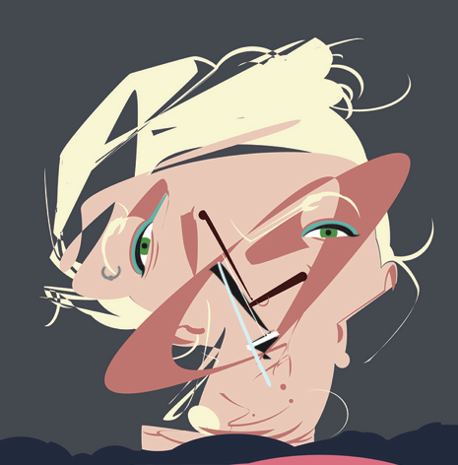

*Image 6 – Chris Finley “Drool, Snatch, Clean and Jerk”, 2017*

Sol LeWitt (American, 1928-2007) is one of the pioneers of instruction based conceptual art that explores fascinating topics such as ownership and the idea of the ‘original’. He reduced his art to its essentials, making the cube his basic grammatical device. LeWitt’s genius was brought to life through a rubric of detailed instructions that his assistants followed to create his wall-sized pieces. In a book edited by Alicia Legg and deigned by Sol LeWitt himself, the progression of the artist’s ideas and career are reflected through his most remarkable art pieces. In “The Location of Straight, Not Straight, and Broken Lines and All Their Combinations” (1976) (Image 7), Sol LeWitt reimagines traditional captions by integrating them into the piece itself. “As this system gets more involved, and more writing must fit into the drawings, the visual results get wilder and wilder until they approach logical insanity” (Lippard, 28). The idea of rules and instructions as a process of creating art has clear connection with the creation of algorithms – a procedure of a finite number of steps leading to a result. While the art was hand-made by humans, it is easy to see the connection of art driven by algorithms, which eventually has become the building blocks of my work as well.

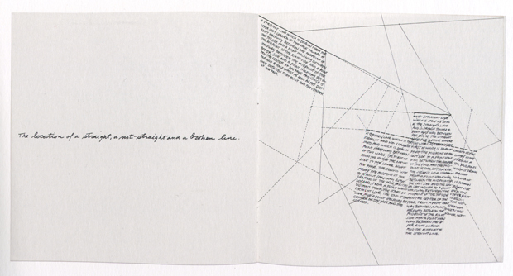

*Image 7 – Sol LeWitt “The Location of Straight, Not Straight, and Bro ken Lines and All Their Combinations” (1976)*

Some further questions arise regarding ownership and authenticity, when code is involved in the creation of art, especially if a large part of it calls for the random() function. If the user is creating a piece of art and the machine interrupts by modifying the output, is it the original? Is it the copy? I often struggle to consider a work of art to be the result of solely my own work, when I have access to tools that enhance or even autocomplete my work. It wouldn’t be surprising to learn that many other interactive media artists feel the same way. Then can anything created with the assistance of a software program be considered an original? This raises interesting questions regarding simulacra, which in Shanken’s book is defined as “a form of similarity particular to media culture, wherein distinctions between original and copy become increasingly murky. The originals may no longer exist, may never have existed, or their significance has been dwarfed in comparison to the simulacra”. While the term ‘simulacra’ has been around since Pluto’s time, it was revitalized and given its current meaning by the French sociologist Jean Baudrillard who examined the relationships between reality, symbols and society. Incorporated in my work, these concepts will allow me to further blur the distinction between a copy and original, between living and artificial, and explore the relationship between a predictable user and an unpredictable machine. This means that while the users are encouraged to create art of their own liking, every exchange is always mediated by the gaze of the computer. Through this peculiar relationship, I will be able to further study the friction between reality and its representations and further test Baudrillar’s hypothesis that “[today] It is the generation by models of a real without origin or reality: a hyperreal.”

**Bibliography**

1 Shanken, Edward A. “Art and Electronic Media. Illustrated Edition.” *NY: Phaidon Press,* 2014.

2 Paul, Christiane. “Digital Art 3rd Edition.” *Thames and Hudson Ltd,* 2015.

3 Baudrillard, Jean. “Simulacra And Simulation*.*”*Ann Arbor: University of Michigan Press,* 1994.

4 Walter Gropius. “Program of the Staatliche Bauhaus in Weimar Walter Gropius, 1919.” *Bauhaus Manifesto.* <https://bauhausmanifesto.com/>. Accessed October 9, 2020.

5 “The LeWitt Collection.” *The LeWitt Collection.* <http://www.lewittcollection.org/about/>. Accessed October 9, 2020.

6 “Chris Finley.” *Artnet.* <http://www.artnet.com/artists/chris-finley/>. Accessed October 9, 2020.

7 “Joseph Nechvatal.” *Artnet.* <http://www.artnet.com/artists/joseph-nechvatal/>. Accessed October 9, 2020.

8 LeWitt, Sol. “Sol LeWitt: the Museum of Modern Art, New York: [exhibition].” *The Museum of Modern Art,* 1978.

9 McCormack, Jon and d’Inverno, Mark. “Computers and Creativity.” *Springer Berlin / Heidelberg*, 2012.

**Attachment 1 – Instructions**

<h3>Your task today: Draw a car</h3>

<ul>

<li>Pick a color that is good for sketching.</li>

<li>Draw two circles next to each other on the same plane - these will be the tires.</li>

<li>Now add the frame of the car. The top of it is dome shape - like the Volkswagen Beetle.</li>

<li>The car is driving towards your right side.</li>

<li>Now add windows. There are two windows - at the driver's seat and the passenger's side.</li>

<li>Now add doors. There are two doors and two door handles.</li>

<li>Color the car in the iconic Volkswagen Beetle color.</li>

</ul>

**Attachment 2 - Introduction**

<title>Mischievous Algorithm</title>

<h3>What is this and how can you participate?</h3>

<p>This is a fun and creative exercise that you will be working on together with your

partner. Each of you will be following the same instructions with some intentional vagueness,

with the goal of creating a collaborative art piece in real time. You are discouraged from communicating with each other in order to test how creative you can get!</p>

<p>There is a fun little twist though. There is a third entity that will be working together with

you today. An algorithm has been created that will from time to time alter your output to make

the process more creative and the result more unpredictable. I challenge you to embrace

this uncertainty and see what you, your partner and the algorithm can create together.</p>

<p>If you don't have a partner with you today, don't worry! When played alone, the game can be a fun way to relieve stress and distract yourself from your responsibilities :) Also, don't tie yourself down to the instructions. Let your creative juices flow!</p>

<h3>Click on the button below to start experimenting and have fun!</h3>